- Create one VPC in N. Virginia region.
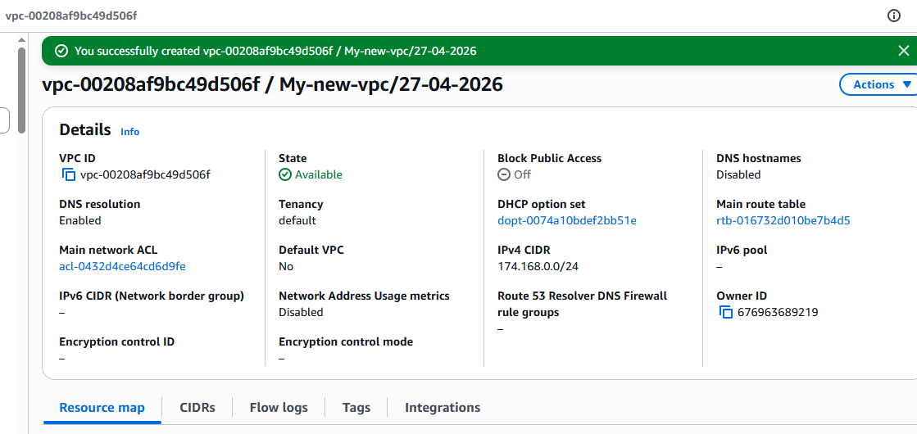
- Create two subnets: one public subnet and one private subnet.
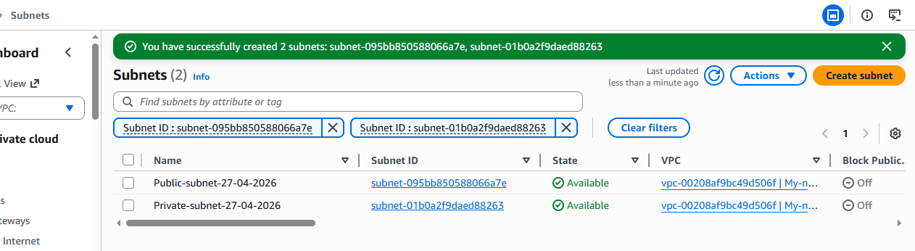
- Attach an IGW to the VPC.
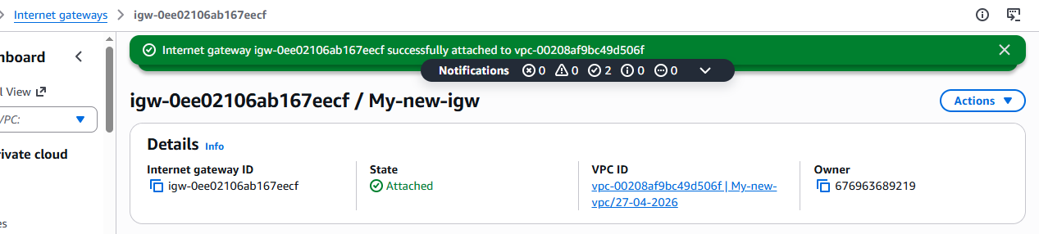
- Create one public route table (RT) and one private route table.
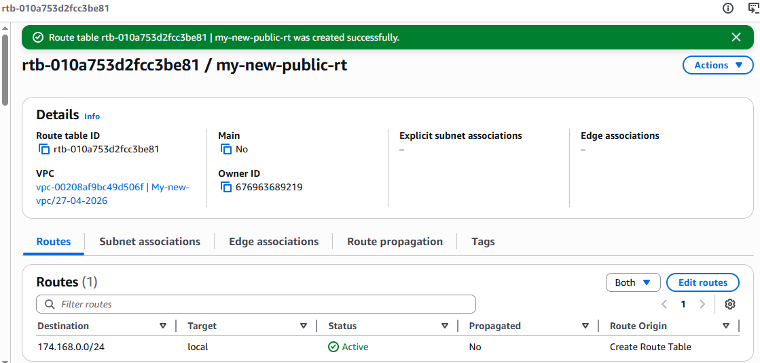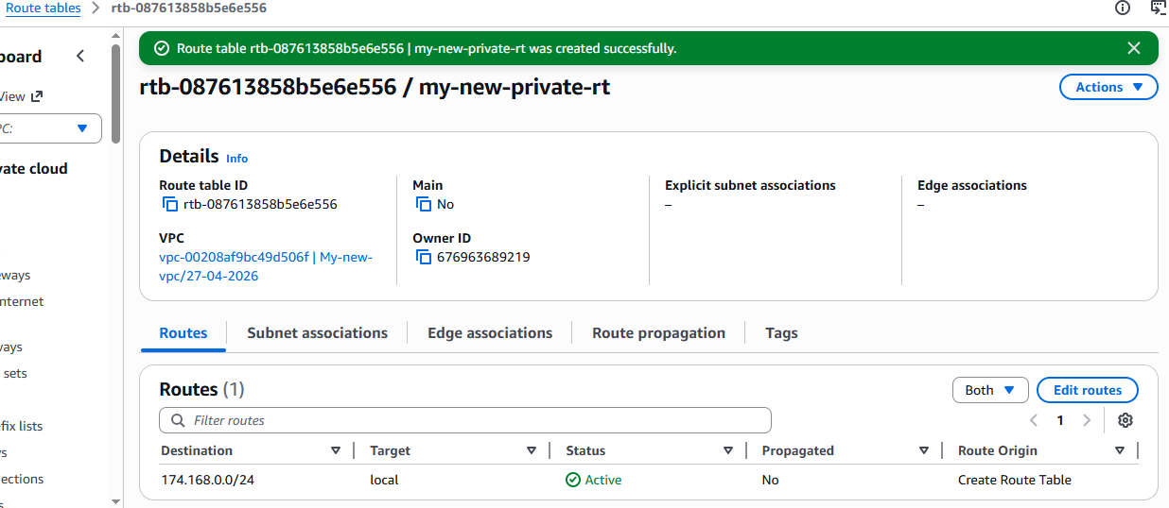
- Deploy a NAT gateway in the public subnet and attach the NAT gateway to the private subnet. 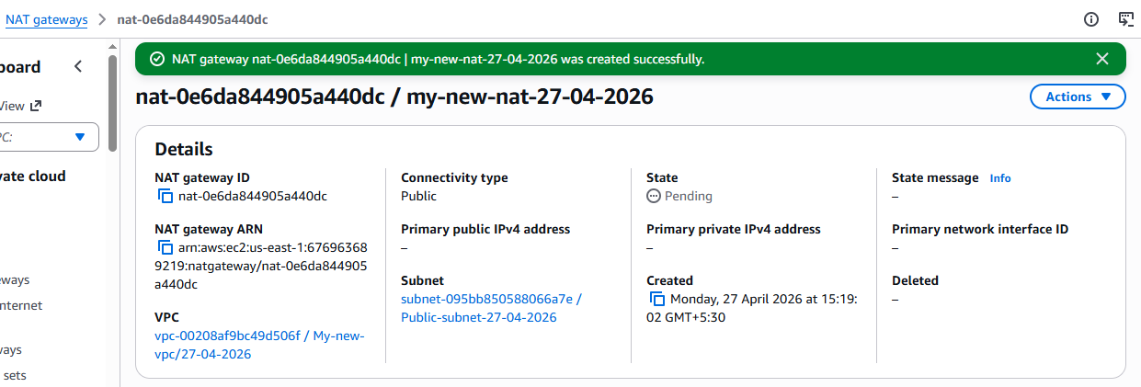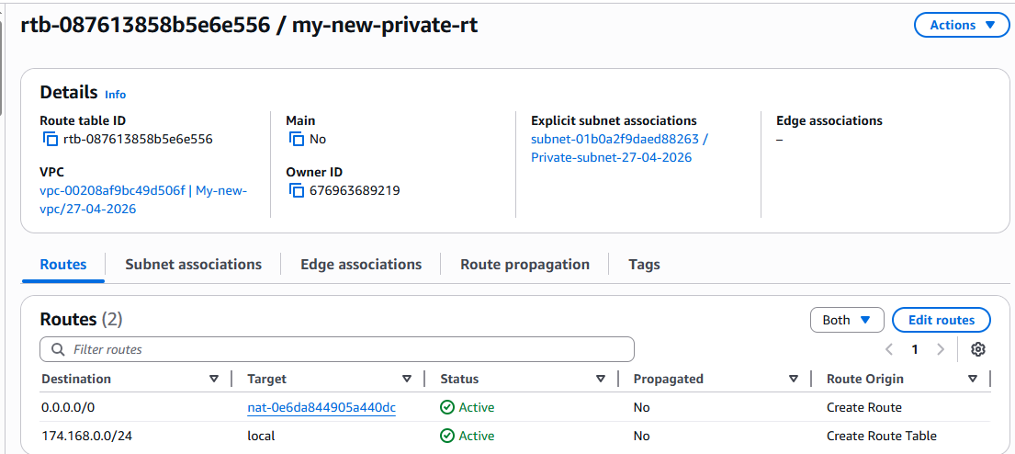
- Create two instances, one in the public subnet and one in the private subnet. 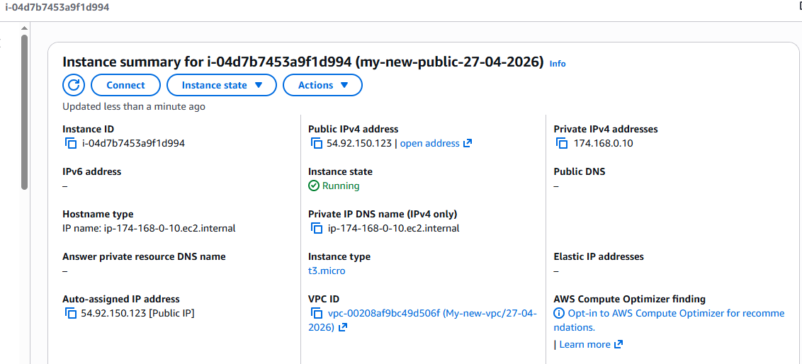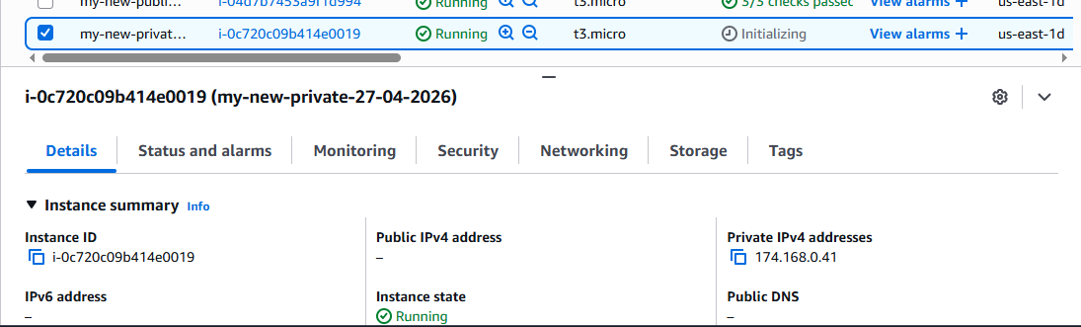
- Deploy Apache server on both EC2 instances with a sample index.html file. 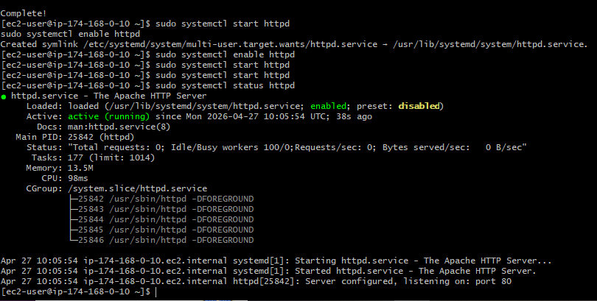 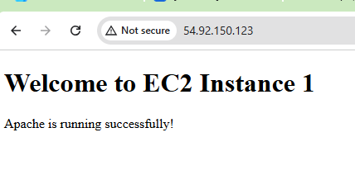
Connected to the private instance via public instance. 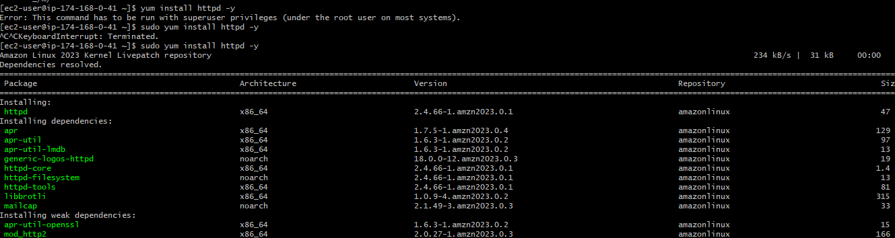
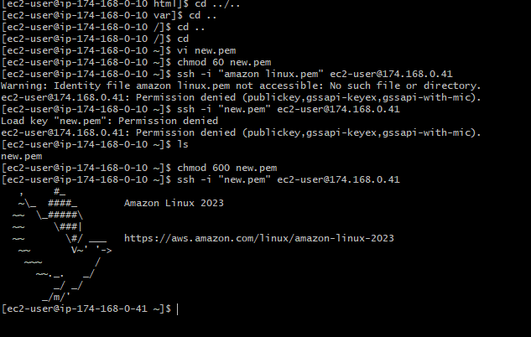 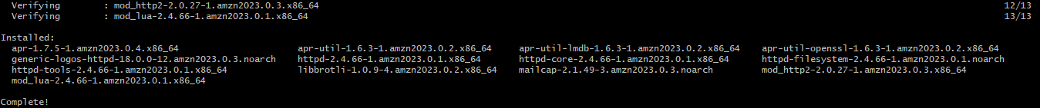 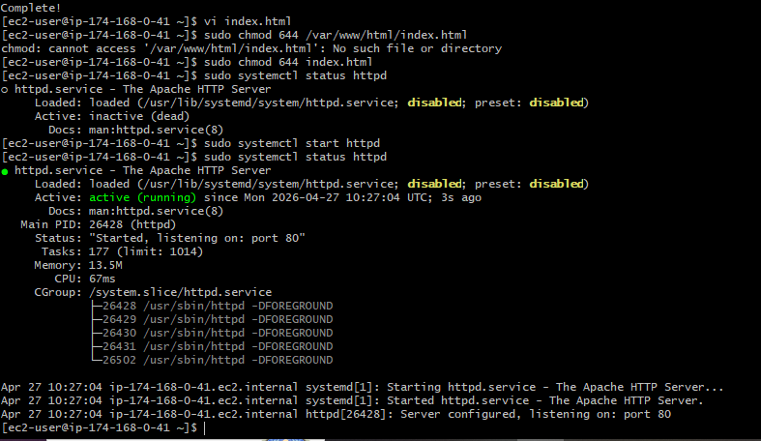
- Create one application load balancer and attach it to both EC2 instances.
created a new load balance and attached the 1 public and 1 private VPC to it. 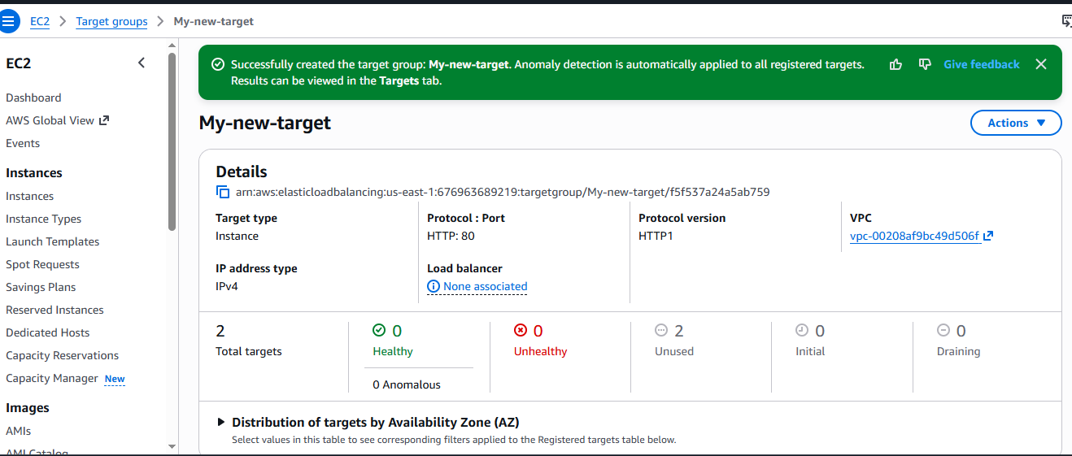 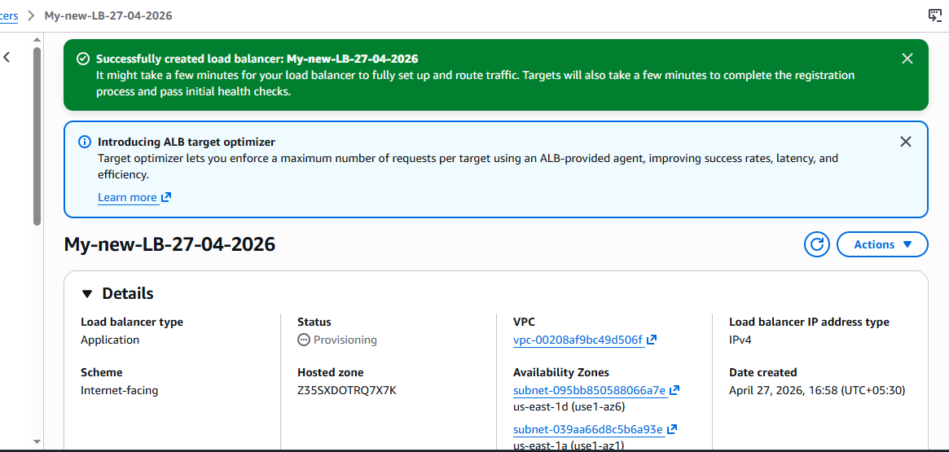
Created a new target group and configured with the 2 instances. 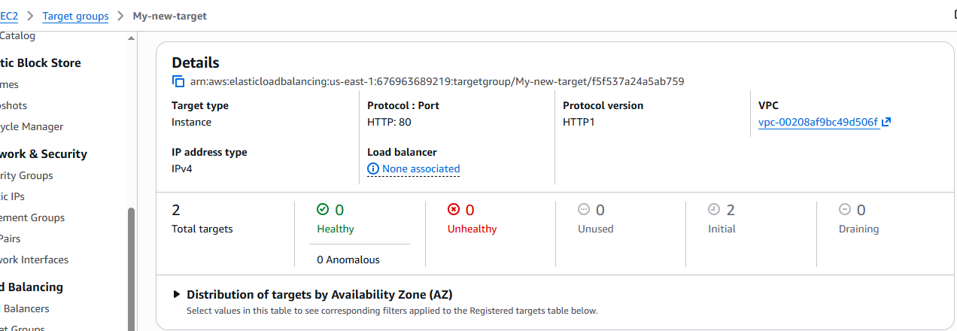
Checked with 2 health and then check with the DNS name with LB in browser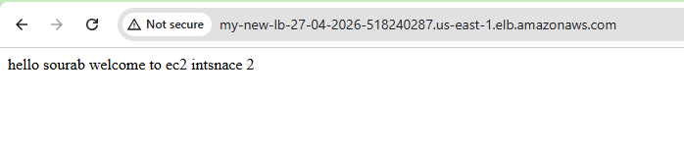
- Store application load balancer logs in S3.
created a new s3 bucket and then provided the bucket policy to it. 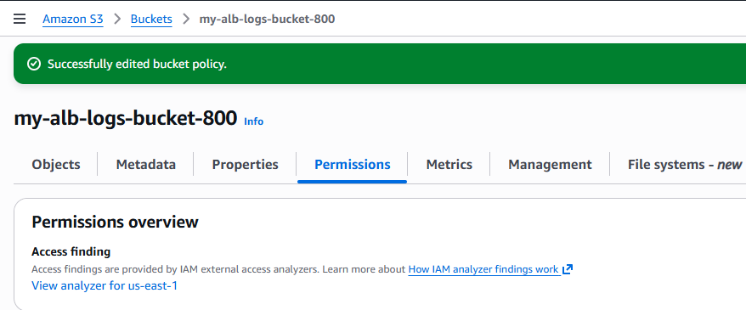
provided access log permission in attributes in load balancer 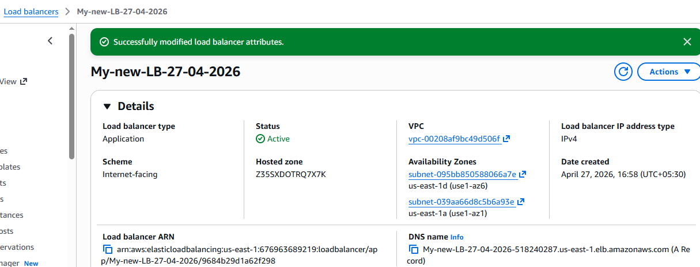checked in the s3 bucket for the load balancer logs 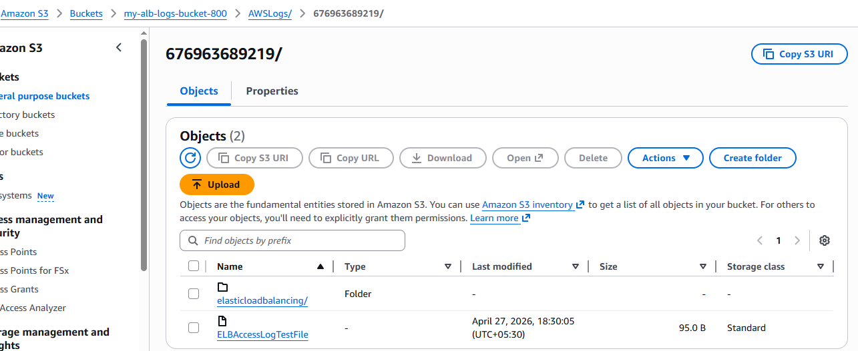
- Store the VPC flow logs in a CloudWatch log group.
Go to VPC and then create a new flowlog and then you will be able to see the same flow logs in cloudwatch.
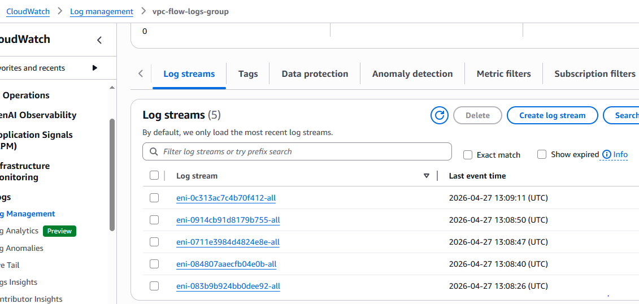
- Create monitoring dashboards to monitor CPU utilization and to monitor the Apache service.
installed cloudwatch agent on public instance 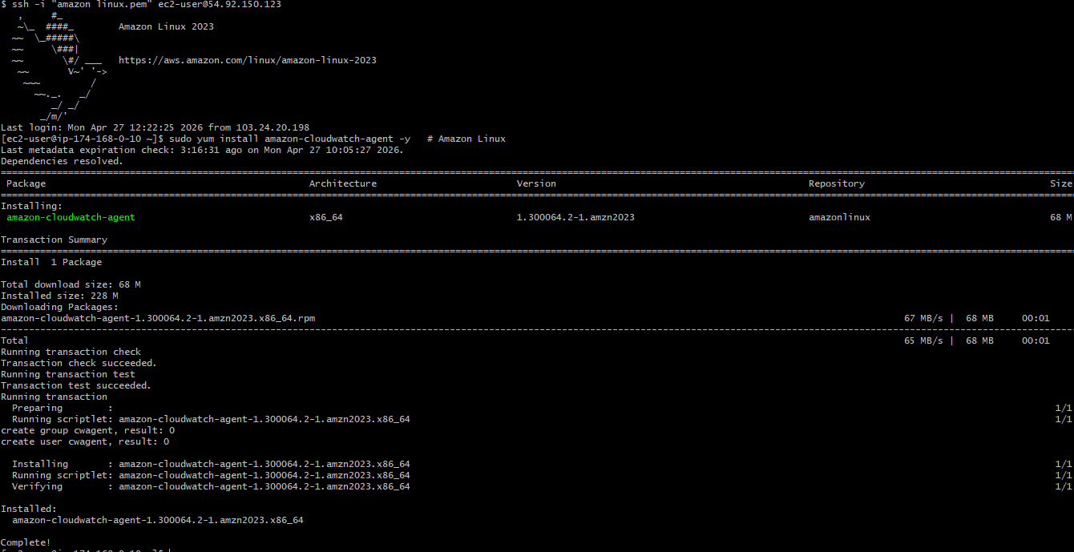installed Cloud watch agent on private instance as well 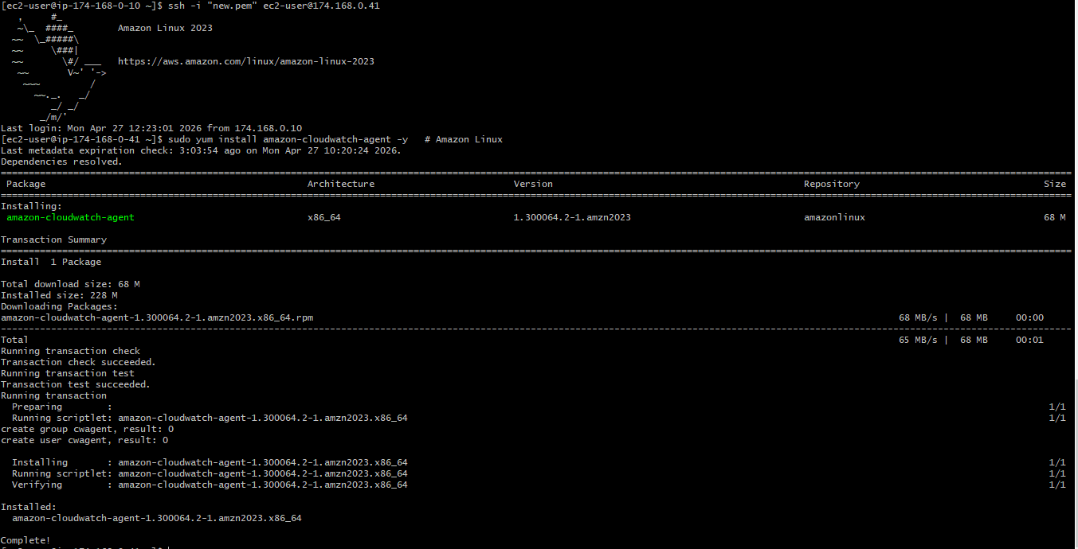created a new dashboard in cloudwatch 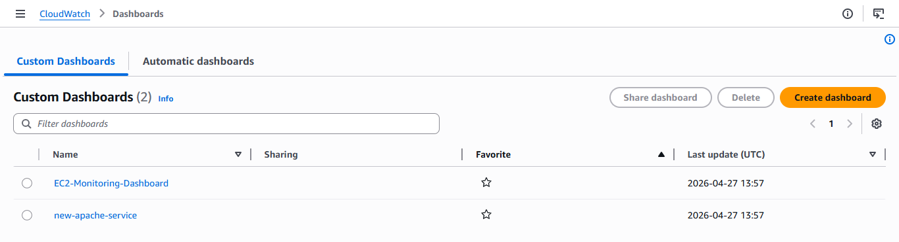
- If CPU utilization is more than 70%, then it should trigger auto scaling and launch new instance.
Created a new instance template with specific information and then created a new auto-scaling group: 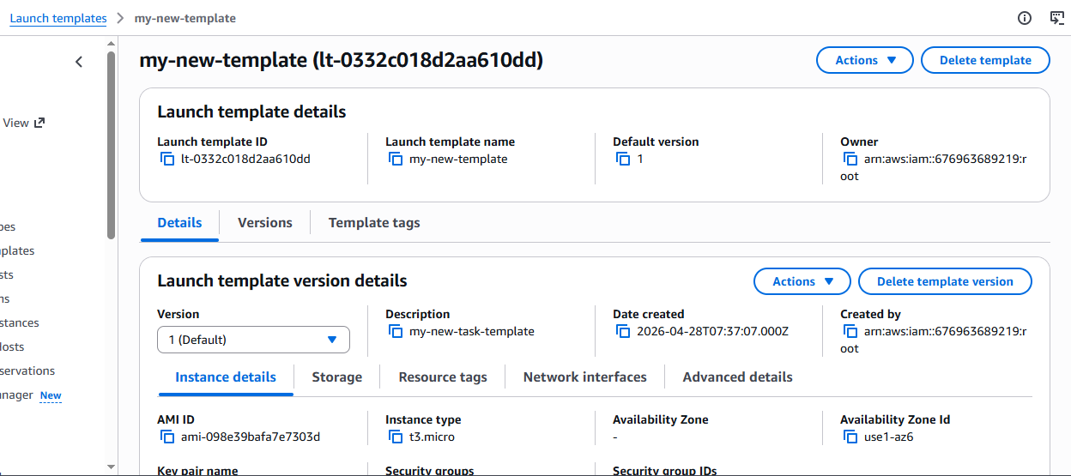
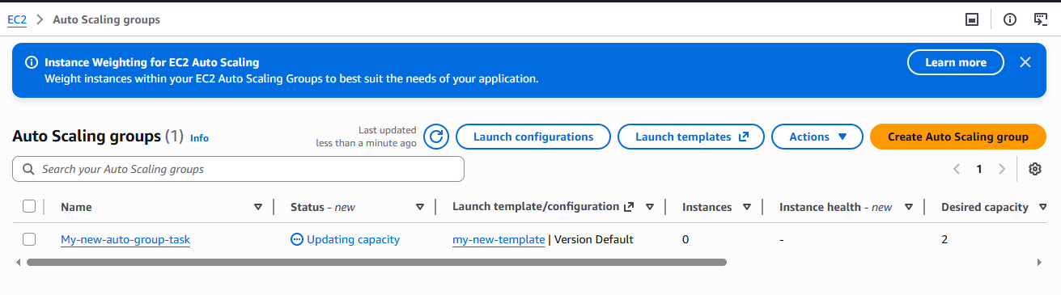
After deleting the first two instances which was created by instance template the new one automatically gets created: last one
